Working with LabVIEW

2017 Season

1. Start FRC 2017 LabView.  
   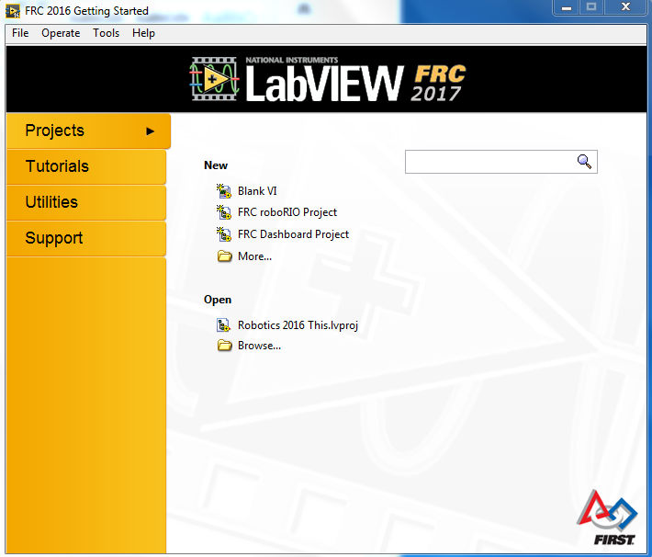
2. Select FRC roboRIO Project.  
   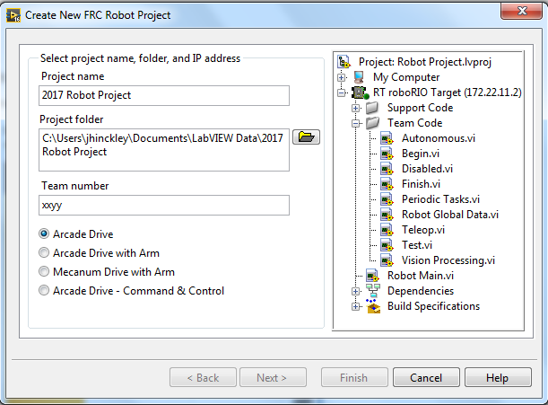
3. Enter parameters:
   1. Project name: Test01
   2. Project folder: C:\Users\jhinckley\Documents\LabVIEW Data\Test01
   3. Team number: 1254
   4. Mecanum Drive with Arm
   5. Press Finish.  
      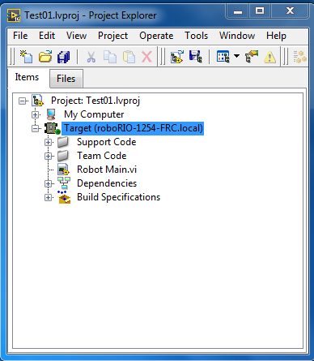
4. Open Robot Main.vi  
   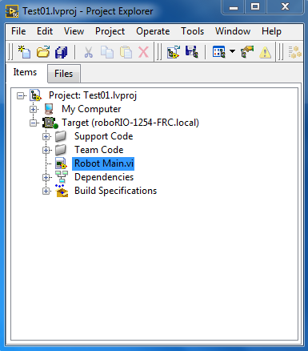
5. Open the code diagram by selecting Window > Show block diagram.  
   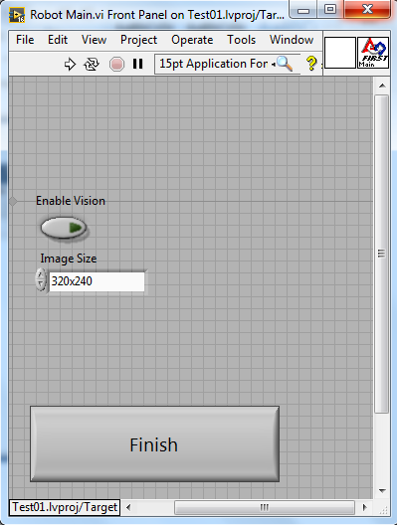
6. This appears:  
   